Homework 2

Question Group 1:

1. Division into layers:  
    Describe the principle of the communications process that divides its actions into layers

•Using the following slide, describe in detail, and the relationship between the layers.

* who transmits, to whom (horizontally peer to peer and vertically between layers),
* how is the process carried out?
* for what purpose?

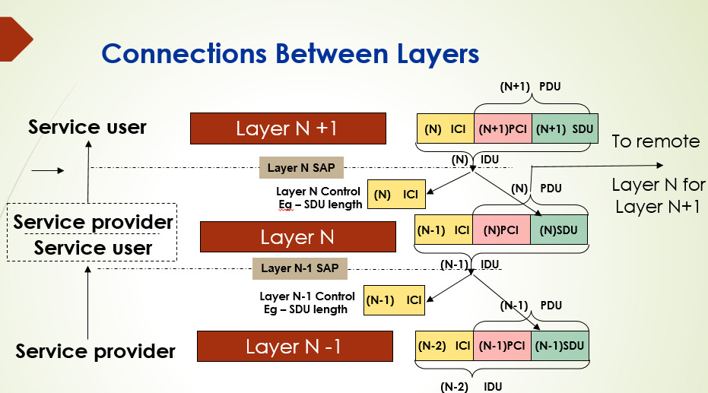

1. For each of the first 4 layers of communications (Layers 1-4) describe for each of the following 4 function: what problem that needed to be solve, and how the problem is dealt with and solved:

* Addresses – (source - destination? Multiplexing?)
* Error Detection/Correction – (Who Caused the Error? How is it detected? What action is taken?)
* Circuit Switching vs. Packet Switching;
* Connection Oriented vs. Connectionless

1. Describe why error detection/correction is required in the second layer and in the fourth layer?
2. There are three planes for the communication service: Data; Control and Management.,

* describe the purpose each plane
* Is there a connection between the planes?
* when will we be satisfied with only some of the planes of communication?
* Can the planes share the communications paths?

1. NMS (network management system) creates messages originating from network equipment,

• Why does the content of these messages not reach the customer equipment

• What is the purpose of the content of the messages.

1. NMS (network management system) יוצר הודעות שמקורם במוצרי הרשת,
   * למה תוכן ההודעות לא מגיע ללקוח ביחידות הקצה.
   * מה יעוד תוכן ההודעות.
2. What is the unit of measurement that is completely relative? And explain your choice.

A) Hertz (Hz)

B) Decibel (dB)

C) Watt

D) Bit rate per second - bps

E) Frames per second fps -

1. Indicate what advantage is there in a signal representing digital information that a signal representing analog information does not have? And explain your answer.

A) The signal strength can be increased with an amplifier

B) Bad SNR can be fixed with a relay (Repeater)

C) Information can be transmitted by modulating a carrier wave

D) Multiple signals can be multiplexed on the same line

E) Signals can be switched from line to line

1. How many logical levels should a signal detect in order to transmit n bits in each symbol in serial communication?
2. log2 n
3. n
4. n2
5. 2n
6. 2n
7. . Explain, describe and detail the following terms:

* Amplitude: ____________________________________________
* Frequency: ________________________________________
* Phase: _______________________________________________.
* Spectrum: ______________________________________________
* Bandwidth: ___________________________________________
* Transmission rate: ___________________________________.

1. . What does SNR represent? What are the impairments that interfere with data traffic? how can these impairments be avoided or fixed? How can we improve SNR?
2. 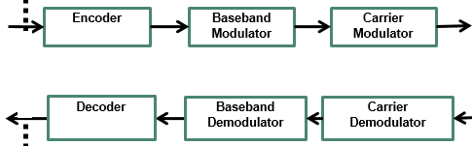Using the following diagram describe the Modulation and Demodulation operation of the Modem   
   Describe the input signal for each stage, and what the signal looks like at its output.
3. . Describe and explain Nyquist's formula / what do we learn from this formula.
4. Describe and explain the Shannon formula / what we learn from this formula compared to the Nyquist formula.

Question Group 2:

1. Given: a data communication channel that connects two stations: Channel settings between station 1 and station 2:

Channel bandwidth 1 MHz (1x106 Hz)

Channel propagation delay is 0.0001 seconds.

The channel broadcasts Symbols at the maximum rate according to Nyquist

In each symbol, two bits are sent

The signal propagation speed in the channel is 2x108 meters per second.

Uses frames with a maximum size of 500 bytes (1 byte = 8 bits)

(All answers are given approximately, show all formulas and calculations)

* 1. What is the distance between station 1 and station 2?

A) 40 km

B) 40 meters

C) 20 km

D) 20 meters

E) 10 meters

F) The previous answers are not close to the correct answer

* 1. What is the maximum bit rate between station 1 and station 2?

A) 16x10^6 bits / second

B) 10x10^6 bits / second

C) 8x10^6 bits / second

D) 4x10^6 bits / second

E) 2x10^6 bits / second

F) The previous answers are not close to the correct answer

* 1. What is the maximum frame rate transmission time between station 1 and station 2?

A) 0.001 seconds

B) 0.002 seconds

C) 0.004 seconds

D) 0.000125 seconds

E) 0.00050 seconds

F) The previous answers are not close to the correct answer

* 1. What is the level of signal-to-noise (SNR) required in the channel between station 1 and station 2 according to a witty law?

A) 6dB

B) 12db

C) 16db

D) 24db

E) 48db

F) The previous answers are not close to the correct answer

1. A noise-free channel with a bandwidth of 5000 Hz and you want to broadcast it at a rate of at least 30,000 bits per second.   
   What is the number of L levels required?

A) 2 levels

B) 4 levels

C) 6 levels

D) 8 levels

E) All previous answers are incorrect.

1. A signal given at a power of 100 mW with a noise of 1 mW.   
    What is the value of the (Signal-to-Noise Ratio) SNR in this case?

A) 10db

B) 20db

C) 30db

D) 40db

E) 60db

1. Suppose 1 PC needs to send a large file to 2 PC, the two computers are on different LANs, and are separated by a chain of routers. What is the longest unit (in homes) that passes through the network from 1PC to 2PC? Explain your choice.

A) Application messages

B) PDU of layer 3

C) Segment

D) PDU of layer 5

E) Frame

1. Assume that the video is broadcast on a 4.5 Mhz bandwidth channel, with SNRdb equal to 35. What is the maximum data rate of the channel (bps)? View the calculation for your answer (formulas and explanation)
2. Suppose you want to send a shipment of CDs with a courier. Each CD contains 8.54 gigabytes of data. Shipping includes 9,000 CDs. The journey time of the courier from the source to the destination is two hours. What is the data rate in the bits of the messenger? View the calculation for your answer (formulas and explanation)

Question Group 3:



Data Communications Model

Among the components of the system drawn in rectangles, six interfaces are numbered 1 to 6.

Here are the three types of interfaces that can serve this model:

* 1. Analog information only interface
  2. Digital (digital) information only interface
  3. . An interface that can be used for analog or digital information

Indicate in the sections below: 1 to 6, what type of interface is most appropriate (A, B or C)?

1. Interface 1: ________

2. Interface 2: ________

3. Interface 3: ________

4. Interface 4: ________

5. Interface 5: ________

6. Interface 6: ________

**Good Luck**